1.)

A. Write a query to display the Ename and Sala of employee whose salary <=2200 ?

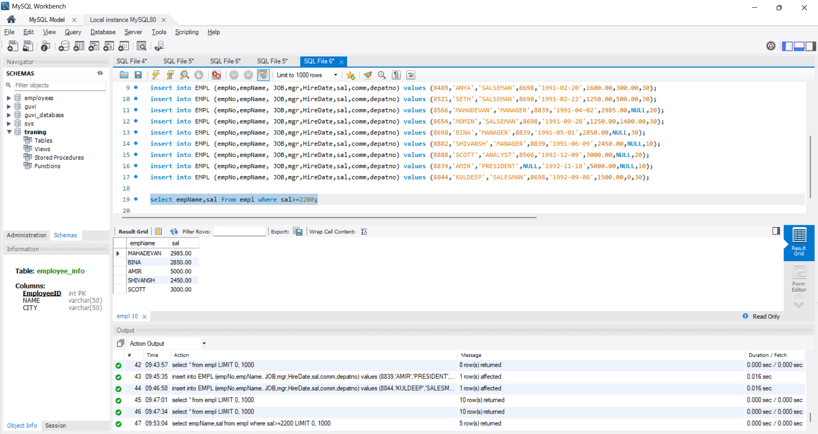

2. Write a query to display empl who are not getting commission?

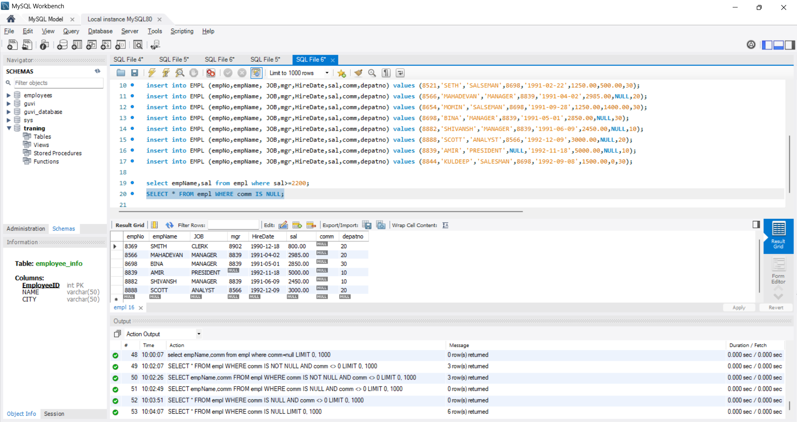

3. Write a query to display the employee name and salary of those employees who do not have their salary in the range of 2500 to 4000,

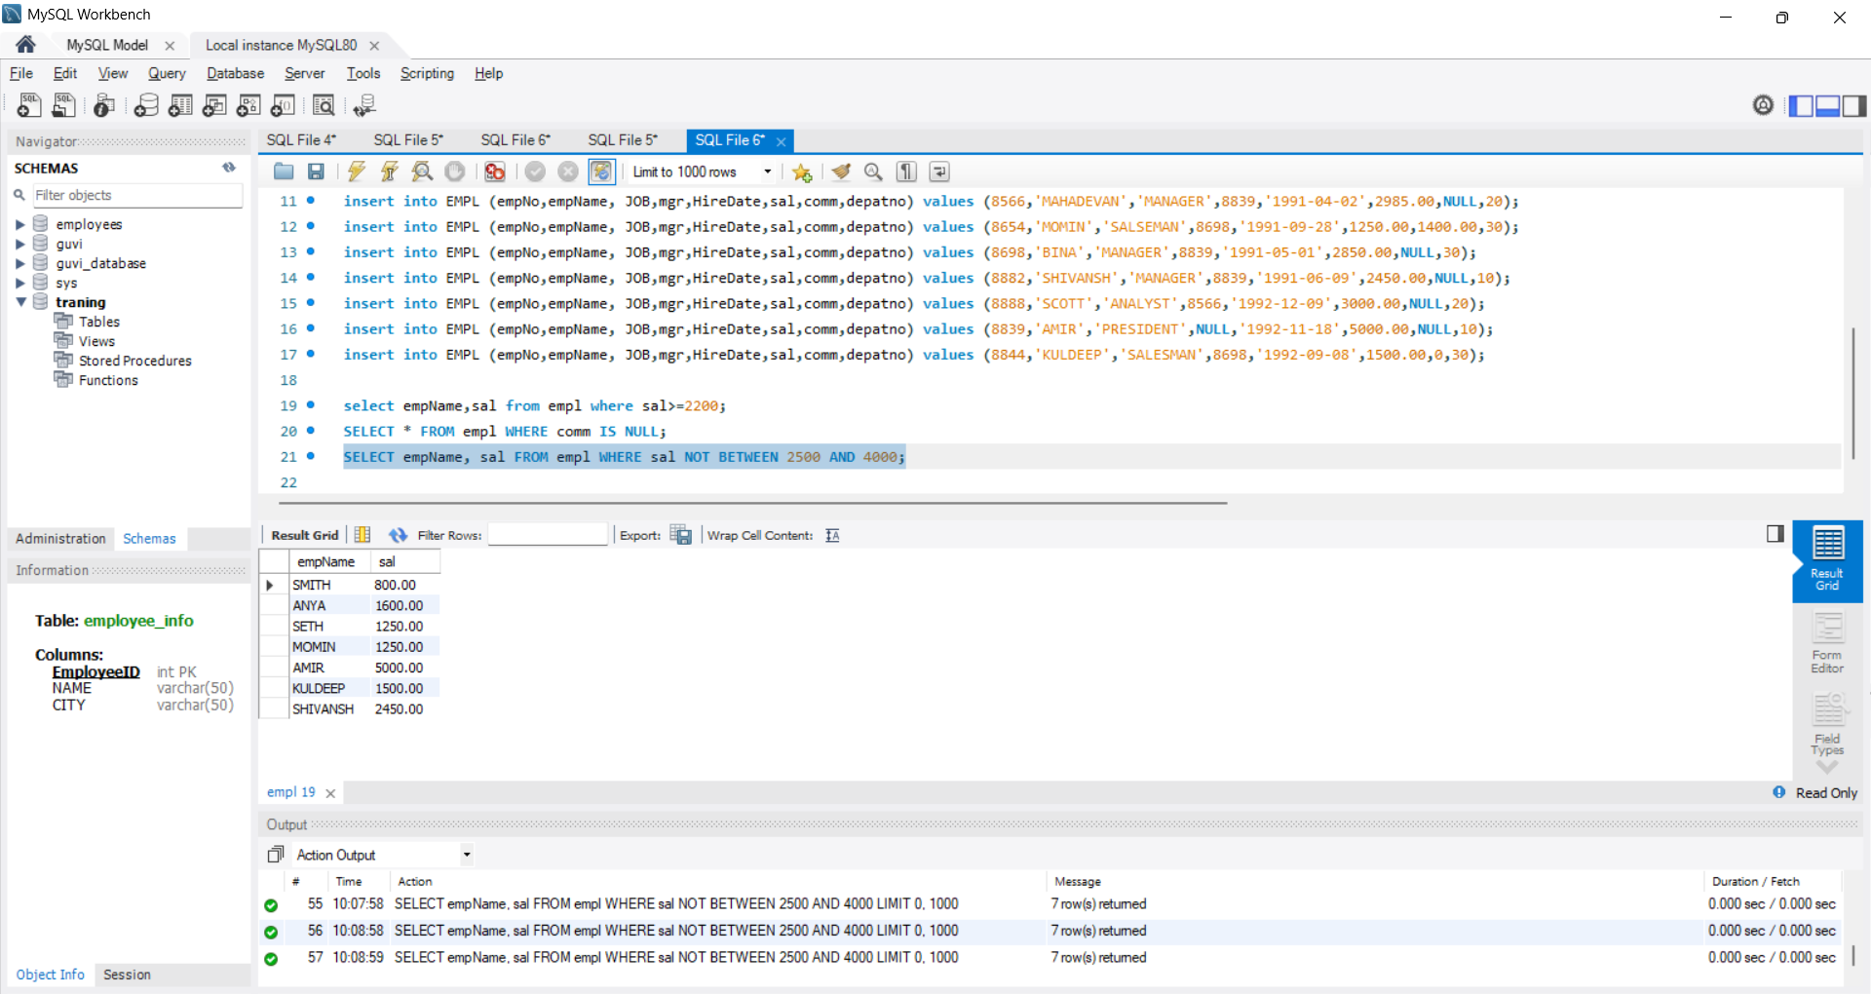

4.Write a query to display the name, job title,salary where don’t have manager

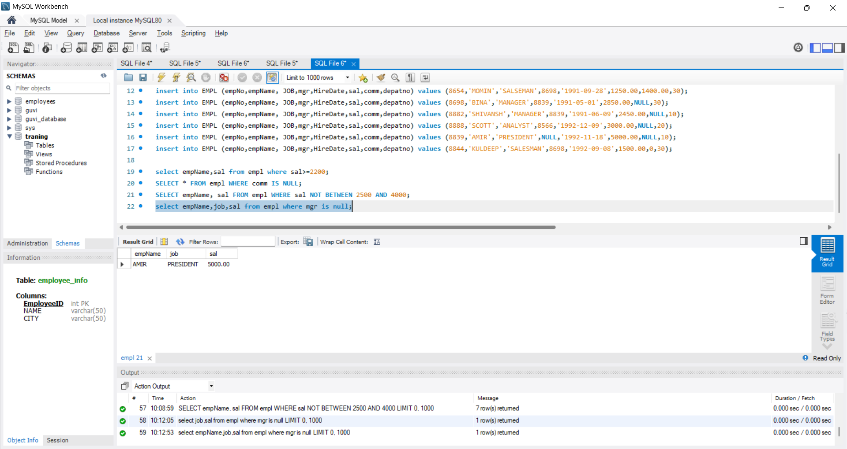

Write a query to display the name of an employee whose name contains 'A' as third alphabet?"

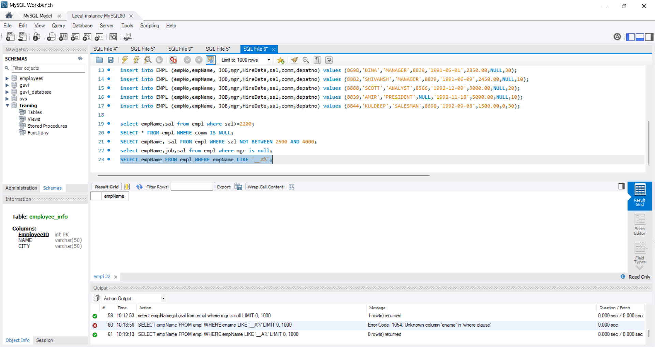

Write a query to display the name of an employee whose name contains 'T' as last alphabet?"

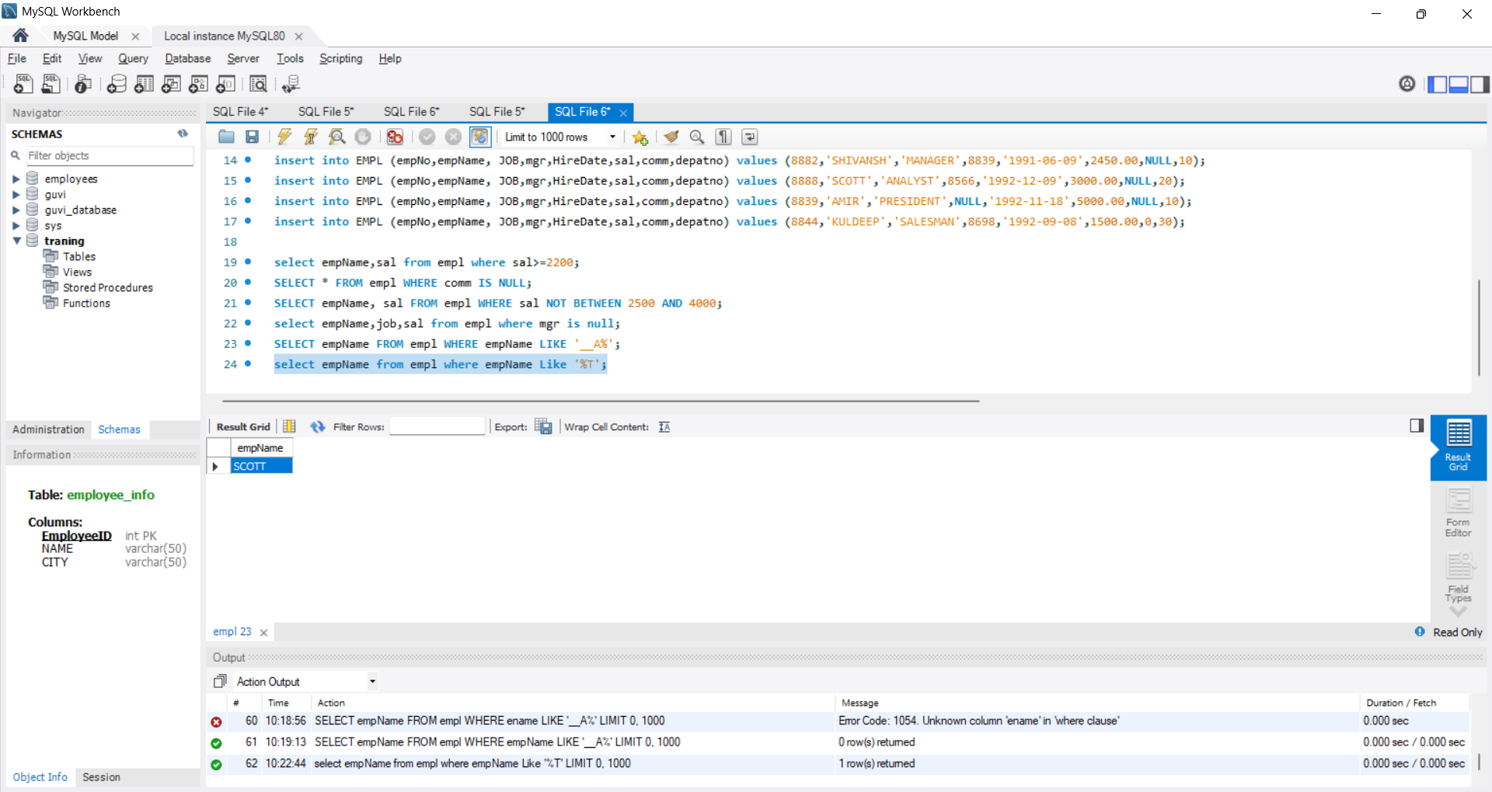

2. JDBC Connectivity and insert the below data

